RESOLUTION NO.__________

RE: CERTIFICATE OF APPROPRIATENESS UNDER THE
PROVISIONS OF THE ACT OF THE PENNSYLVANIA
LEGISLATURE 1961, JUNE 13, P.L. 282 (53
SECTION 8004) AND BETHLEHEM ORDINANCE NO.
3952 AS AMENDED.

WHEREAS, it is proposed to install a new window on the south wall at 438 Center St.

NOW, THEREFORE, BE IT RESOLVED by the Council of the City of Bethlehem that a Certificate of Appropriateness is hereby granted for the proposal.

Sponsored by: (s)

(s)

ADOPTED BY COUNCIL THIS DAY OF

(s)
President of Council

ATTEST:

(s)
City Clerk

HISTORICAL & ARCHITECTURAL REVIEW BOARD

The applicant has installed one new window on the south wall at 438 Center St.
APPLICATION #2:

David Bayer
438 Center St.
Bethlehem, PA 18018

OWNER:

__________________________________________________________________________

The Board upon motion by Phil Roeder and seconded by Diana Hodgson adopted the proposal that City Council issue a Certificate of Appropriateness for the following:

- Replacement window with brick molding trim.

2. Window and trim to be painted white to match existing.

3. The motion was unanimously approved.

__________________________________________________________________________

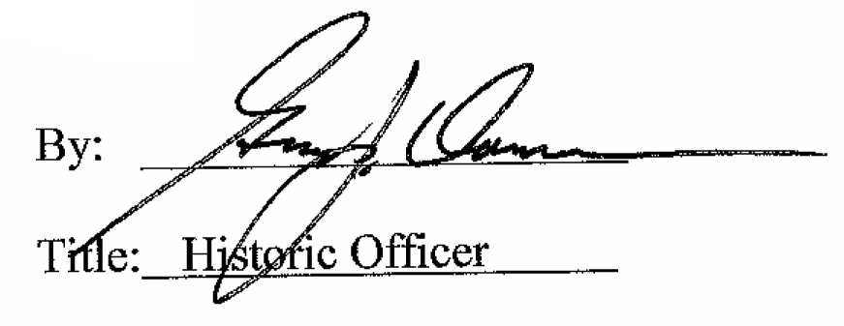

Date of Meeting: August 2, 2017

